

**LocAdoc**

**Component Design Document (CDD)**

**Version 0.1**

**Prepared by: Abhi Jay Krishnan**

**Kim Hyeocheol**

**Rivaldo Erawan**

**Durrah Afshan**

Table of Contents

1. Introduction 1

2. Component Design 1

2.1 Component Diagram 1

2.2 Component Description 1

2.2.1 User Authentication View Component 1

2.2.2 File Management View Component 1

2.2.3 User Management View Component 2

2.2.4 User Authentication Presenter Component 2

2.2.5 File Management Presenter Component 2

2.2.6 User Management View Component 3

2.2.7 Data Store View Component 3

2.2.8 Security Component 3

2.2.9 AWS Cognito Component 3

2.2.10 AWS Dynamo DB 3

2.2.11 AWS S3 3

3. Appendix A: Glossary 4

4. References 5

# Introduction

The purpose of this document is to show all the components that build the system and the relationship among them. Each of these components will be described in detail including all the classes within it.

# Component Design

## Component Diagram

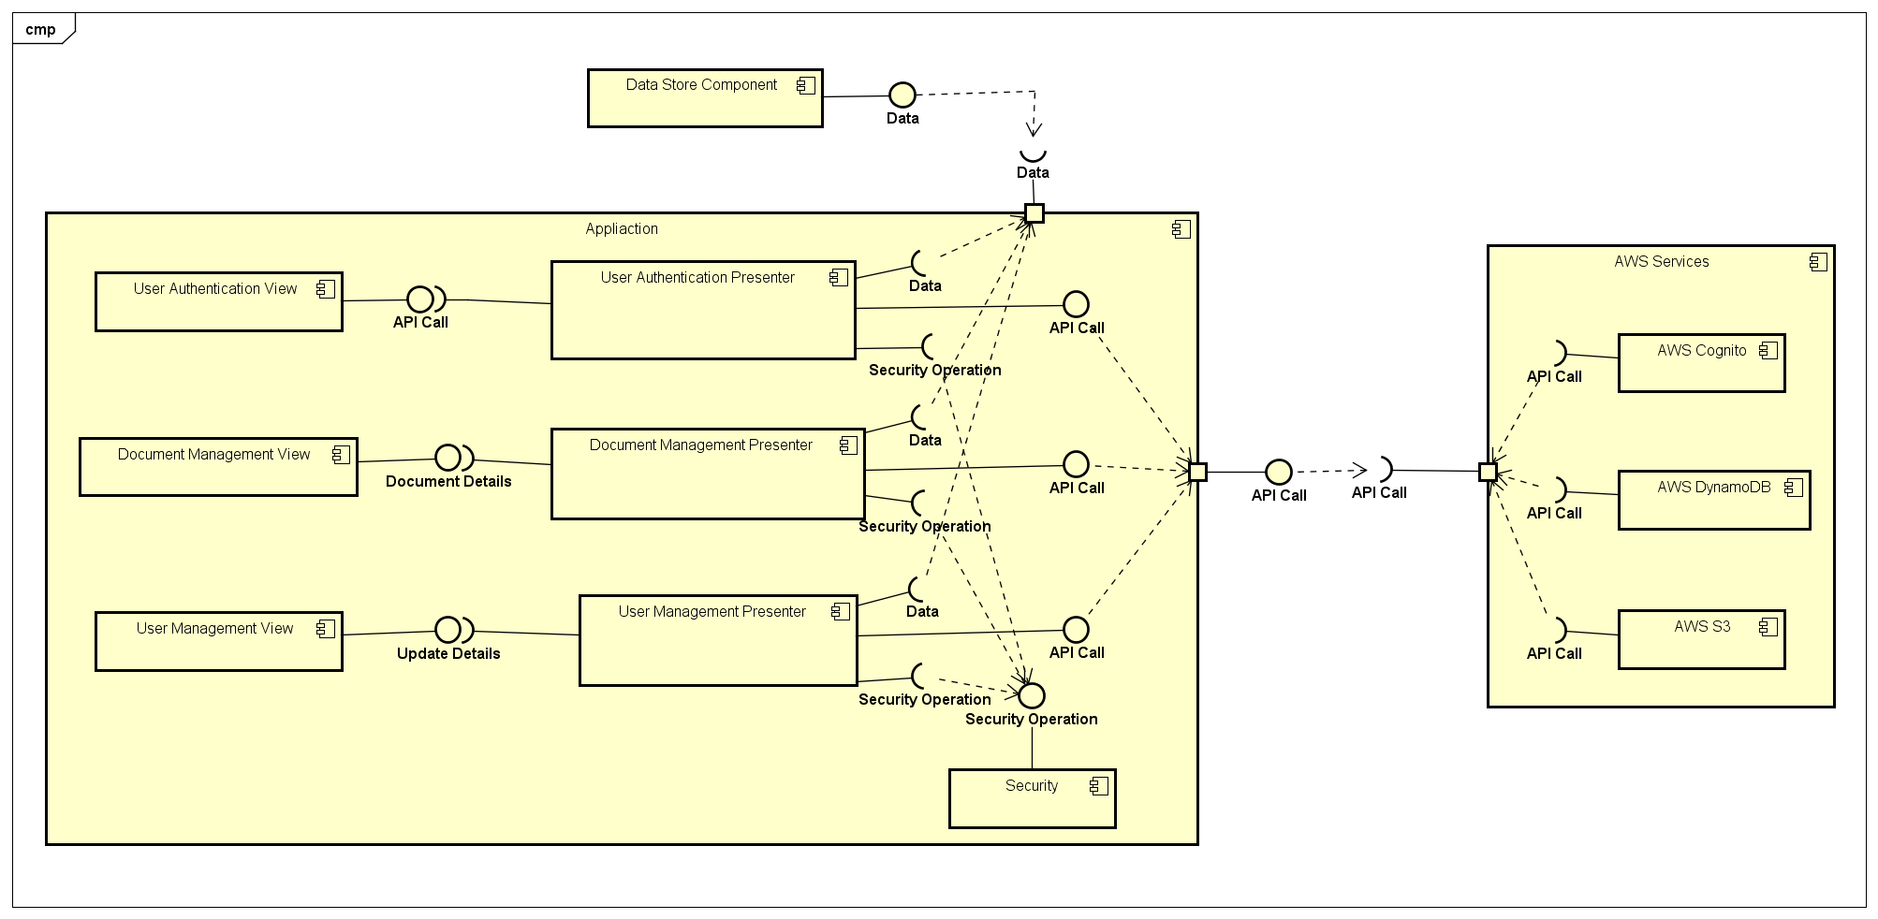

Figure 1: Component diagram

## Component Description

### User Authentication View Component

This component consist of classes that will show the UI (User Interface) for authenticating user and call its presenter when the user interact with it. The classes are as follow:

* **Home View**

The UI (User Interface) when user first open the application. It gives user the option to create new account (sign up) or log in with existing account.

* **Log in View**

The UI (User Interface) for user to log in with existing account. All details are entered and a log in button will call its presenter

* **Reset Password View**

The UI (User Interface) for user to reset password if the user forget its current password

* **Sign up View**

The UI (User Interface) for user to create a new account. All details are entered and a sign up button will call its presenter

### File Management View Component

This component consist of classes that will show the UI (User Interface) for creating, viewing, or deleting a file, and then call its presenter when the user interact with it. The classes are as follow:

* **Document Explorer View**

The UI (User Interface) when user want to explore directory and select a particular file

* **PDF Viewer View**

Open and display a pdf file. This view is controlled by its presenter

* **Import Document View**

The UI (User Interface) for user to select a file in local storage and import it to the application

### User Management View Component

This component consist of classes that will show the UI (User Interface) for managing user’s details, and will also include backup. The classes are as follow:

* **Settings View**

The UI (User Interface) when user want to view its details and/or change its particulars as well as to backing up its data.

* **Change Password View**

The UI (User Interface) for user to enter its new password and submit the form. Submitting the form will call its presenter

* **Backup View**

The UI (User Interface) for user to confirm to back up its data. Confirming will call its presenter

### User Authentication Presenter Component

This component consist of classes that will handle all the user authentication, and make API call to AWS (Amazon Web Services) to do the operation. It makes use of Security Component and will update the Data Store Component. The classes are as follow:

* **Home Presenter**

It will decide whether to bring user to Log in View or Sign up View based on the input

* **Log in Presenter**

All logics related to authenticating user and decide on which view next to show, this includes API call to AWS Cognito

* **Reset Password Presenter**

All logics related to resetting user’s password and decide on which view next to show, this includes API call to AWS Cognito

* **Sign up Presenter**

All logics related to creating new user and decide on which view next to show, this includes API call to AWS Cognito and AWS DynamoDB

### File Management Presenter Component

This component consist of classes that will handle creating, viewing, and deleting a file; and make API call to AWS (Amazon Web Services) to do the operation. It makes use of Security Component to encrypt/decrypt the files and will update the Data Store Component. The classes are as follow:

* **Document Explorer Presenter**

All logics related to exploring file and decide on what operation done to this file based on the user input (view or delete). This might include API call to AWS DynamoDB and AWS S3. After that it decides on which view to go next.

* **PDF Viewer Presenter**

Decrypt selected file using Security Component and display it on screen. After user close the PDF Viewer View, encrypt back the file and display back Document Explorer View. This will include logic to constantly check user’s location

* **Import Document Presenter**

All logics related to selecting a file in the local storage and save it to the application, Security Component will be used here to encrypt the file. This will include API call to AWS Dynamo DB. After that it decides on which view to go next.

### User Management View Component

This component consist of classes that will handle updating user’s details and backup. API call to AWS (Amazon Web Services) is done to do the operation. It makes use of Security Component and will update the Data Store Component. The classes are as follow:

* **Settings Presenter**

All logics related in making changes to user’s particulars and backing up data. This might include API call to AWS Cognito, AWS Dynamo DB, and AWS S3. After that it decides on which view to go next.

* **Change Password Presenter**

All logics related in changing the user’s password, this includes API call to AWS Cognito and AWS Dynamo DB. After that it will display back Settings View.

* **Backup Presenter**

All logics related to back up user’s data, this include API call to AWS Dynamo DB and AWS S3. After that it will display back Settings View.

### Data Store View Component

This component consist of classes that are used to save information about an item/entity. These classes are mainly used for AWS Dynamo DB and SQLite. Local database SQLite is also included in this component. The classes are as follow:

* **User**

Keeping all the user’s information that are listed in the DDD (Database Design Document)

* **Area**

Keeping all the area’s information that are listed in the DDD (Database Design Document)

* **Password**

Keeping all the password’s information that are listed in the DDD (Database Design Document)

* **File**

Keeping all the file’s information that are listed in the DDD (Database Design Document)

### Security Component

This component consists of all security operation needed for the system. All of this operation will be: encryption algorithm, decryption algorithm, file encryption algorithm, file decryption algorithm, encoding, decoding, and hash.

### AWS Cognito Component

AWS Cognito is a part of AWS that will be used by the system for managing the users of the system

### AWS Dynamo DB

AWS Dynamo DB is a part of AWS that will be used by the system to act as a database for keeping all information about

### AWS S3

AWS S3 is a part of AWS that will be used by the system to keep user’s file for back up so that it can be retrieved later

# Appendix A: Glossary

**User Interface (UI)**: The front end of the system through which the user interacts with the system functionalities.

**AWS (Amazon web services):** Is a subsidiary of Amazon.com that provides on-demand cloud computing platforms to individuals, companies and governments, on a paid subscription basis.

**Cognito:** Amazon Cognito is an Amazon Web Services (AWS) product that controls user authentication and access for mobile applications on internet-connected devices.

**DynamoDB:** Amazon DynamoDB is a fully managed proprietary NoSQL database services that is offered by Amazon.com as part of the Amazon Web Services portfolio.

**S3 (Simple Storage Service):** A cloud storage service provided by amazon web services.

**DDD (Database Design Document)**: Document that describe the design of the database, including the table and its elements

# References

|  |  |
| --- | --- |
| [1] | Amazon, "AWS Mobile SDK," Amazon, [Online]. Available: https://aws.amazon.com/mobile/sdk/. |
| [2] | Amazon, "Amazon Cognito," Amazon Web Services, [Online]. Available: https://aws.amazon.com/cognito/. |
| [3] | Amazon, "Amazon DynamoDB," Amazon Web Service, [Online]. Available: https://aws.amazon.com/dynamodb/. |
| [4] | Amazon, "Amazon S3," Amazone Web Services, [Online]. Available: https://aws.amazon.com/s3/. |
| [5] | SQLite, "SQLite," SQLite, [Online]. Available: https://www.sqlite.org/. |